Installation Instructions

(For both Standard, Navigator & CD300 Screens)
Thanks for buying my screens. As with most things in life, there is a right way and a wrong way to install them. Please take your time and relax, look at my pictures and go slowly.
Caution! If you use force, the screen frame can be easily bent. The best results come by using steady, gentle pressure using only your fingers. If you do bend them, all is not lost. Follow the repair directions below. But try not to bend them; it will take time away from sailing. Navigator screens may require a bit more pressure to seat correctly.
It is a good idea to wipe a little Silicone Lubricant or Armor All on the black rubber portlight seals before you install my screens.
Standard screens have two grooves on the top left while Navigator screens have four grooves.
Inside, Press in against the tabs method. 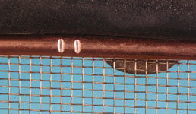 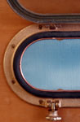 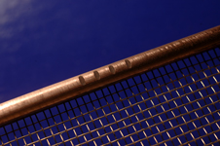
From inside the cabin, with the soldered side out and the edge with the two grooves on the top left, insert the screen into the portlight, centering while lifting the screen upward against the top two tabs and the port light's housing as photo 1 and 2 shows. Then press in the bottom two tab points at the same time as in #3.
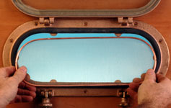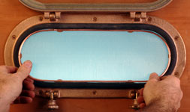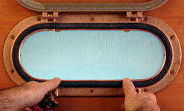
1
2
3
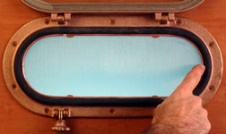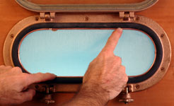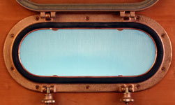
5
4
6
After that, press in the frame, not the screen, at the six tab points until the screen frame seats snugly up against each tab. Remember, steady, gentle pressure with your fingers. This method should work for most installations and hold the screen in tightly.

Installation Instructions
(For both Standard and Navigator Screens)
Continued

To remove the screens This is a two-person job and is done from the outside by pressing against the screen frame till it pops out into the waiting hands of your helper. For you solo circumnavigators, I am sure you can come up with a clever way to keep the screen from falling out and marking up all that nice Cape Dory cabin joinery. If, for some reason, you bend the frame, it is easy to shape it back to its original plane. Simply lay the screen on a flat, sturdy surface and using hammer, lightly tap the protruding parts of the frame. Keep flipping the screen over and work both sides until the screen sits flat against the surface. Lightly tapping are the key words here. If you dent the frame, lay it with screen side down on a piece of cardboard. Try shaping the frame using your fingers pressing it outward as you work up the edge. A small block of wood, a hammer and an extra set of hands to hold the screen could be used if you are careful. Try not to rip the screen.
Enjoy the screens and go sailing. John
John Danicic
4220 Scott Terrace
Edina, MN 55416
john@johndanicic.com
Cleaning. If you are in a spit and polish mood and want to impress the admiral, letting the screens soak in a 1 to 1 or stronger solution of vinegar and water for an hour will brighten up the mesh and the copper frames. An old toothbrush maneuvered around the soldered face will scrub off the salt crystals. jd

